DAY :6 INTRODUCTION TO NETWORK DEVICE THEORY
- Create a table listing the main functions and typical ports used by switches, routers, hubs, firewalls, and access points in a home WiFi setup.
Answer

Home Wi-Fi devices: functions and typical ports
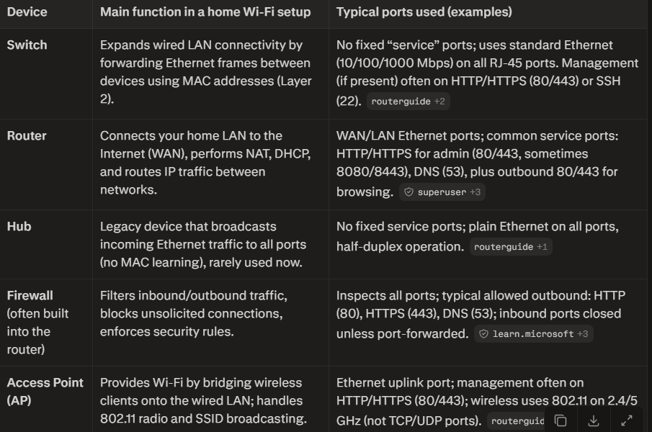

- Given images or diagrams of network devices, label each device and mark the ports (Ethernet, console, power, antenna) for at least three devices.
Answer
1. Enterprise Router (e.g., Cisco ISR Series)
Enterprise routers route traffic between distinct IP networks and provide management access for configuration. 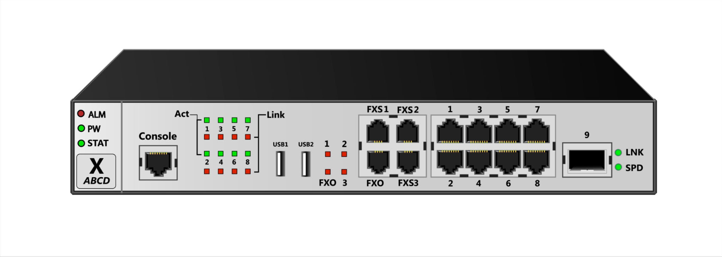
- Console Port: Usually an RJ-45 or mini-USB port labeled Console (often highlighted in blue). Used for out-of-band serial management via a terminal emulator.
- Ethernet Ports (LAN/WAN): RJ-45 Gigabit Ethernet ports labeled GE0/0/0, GE0/0/1, or WAN. These connect to the internal switch fabric or upstream Internet Service Provider (ISP) connections.
- Power Connector: Located on the rear panel; typically a standard IEC AC power inlet or a terminal block for DC power input.
- Antenna Mounts: Optional RP-SMA or N-connector threaded ports on modular expansion cards (NIMs) for LTE/5G cellular failover or Wi-Fi extensions.
2. Consumer Wireless Router / Access Point
Home and small-office routers combine a router, firewall, switch, and wireless access point into a single chassis. 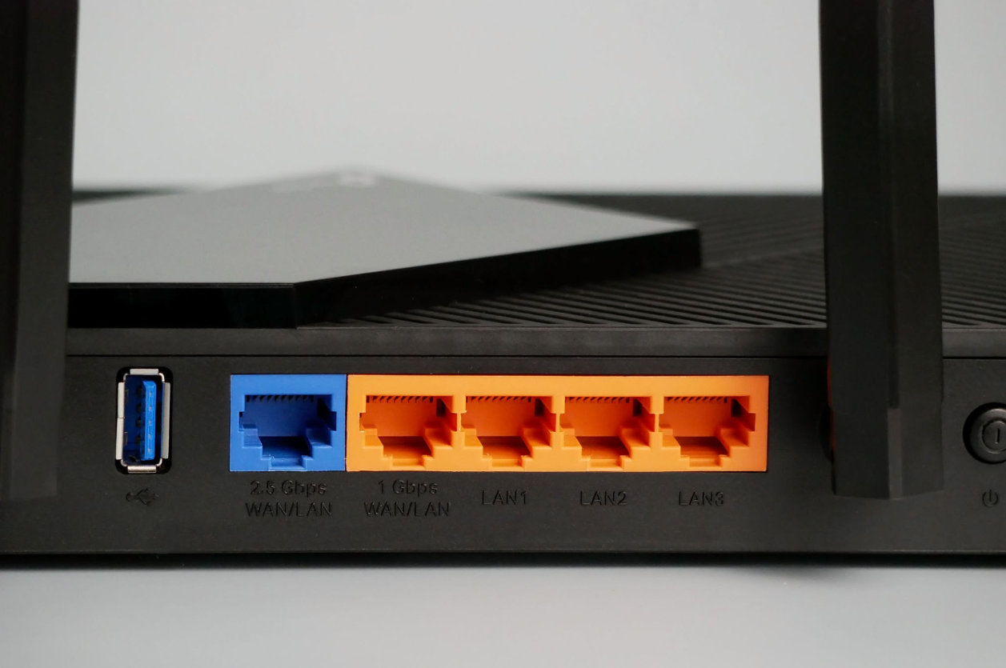
- Ethernet Ports (LAN): Typically 4 yellow or orange RJ-45 sockets labeled LAN 1–4 for local wired devices (PCs, TVs, printers).
- Ethernet Port (WAN / Internet): A distinct blue RJ-45 socket labeled WAN or Internet connecting directly to your modem or fiber ONT.
- Antenna Connectors / Antennas: External adjustable omnidirectional dipole antennas mounted to the top or rear for 2.4 GHz, 5 GHz, and 6 GHz Wi-Fi transmission.
- Power Port: A small round DC barrel jack labeled Power or 12V DC, accompanied by a power push-button switch.
3. Managed Ethernet Switch
Managed switches operate primarily at Layer 2 to connect multiple local end-devices within the same local area network (LAN). 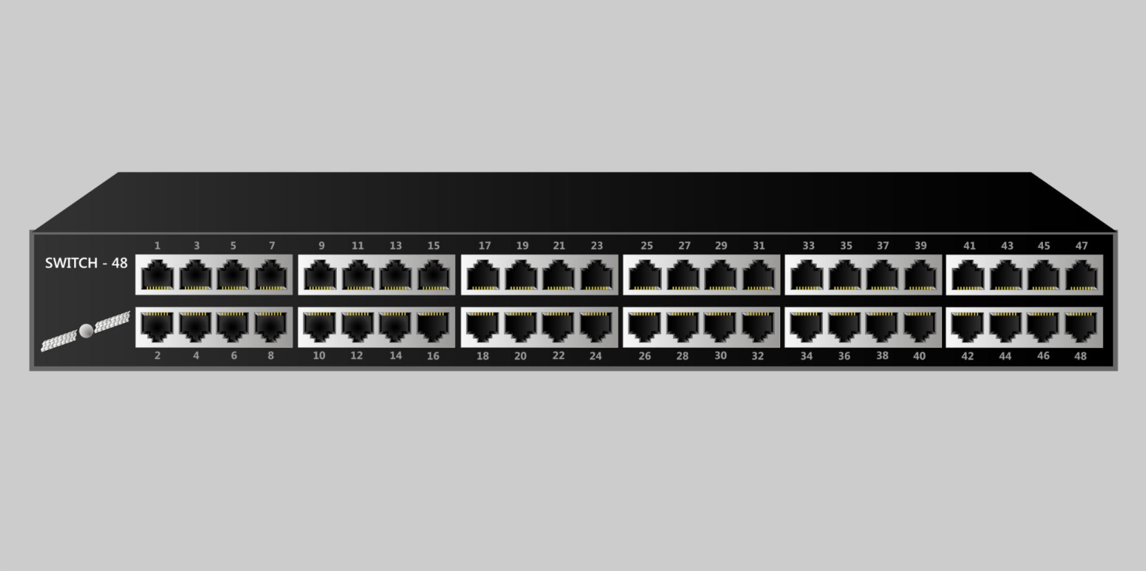
- Ethernet Ports (RJ-45): A high-density array of RJ-45 ports (e.g., ports 1–24 or 1–48) for connecting PCs, IP phones, and access points.
- Console Port: Located on the front or rear panel (often labeled Console or MGMT); used for command-line interface (CLI) setup.
- Uplink Ports (SFP/SFP+): Fiber optic transceivers on the far right used to chain switches or connect back to core routers.
- Power Inlet: Located on the rear left or right side; standard 3-pin AC power connection (IEC C14).

- Pick a popular app you use daily (like Instagram, Zomato, or Paytm) and describe in 3-4 lines how at least two different network devices (from switches, routers, firewalls, access points) play a role when you use that app.
Answer
I’ll use Zomato as the example app.
When you open Zomato on your phone, your traffic first goes over Wi-Fi to the access point, which bridges your wireless connection onto the wired LAN. From there, the router (with its built-in firewall) sends your requests out to the Internet, performs NAT, and blocks unsolicited inbound connections while allowing your outbound HTTP/HTTPS traffic to Zomato’s servers. Inside larger networks (e.g., office or café), a switch then forwards frames between the router, access point, and other devices so multiple users can use Zomato at the same time without collisions.

- Suppose your college Wi-Fi is slow and sometimes disconnects. Based on the features of access points, switches, and routers, suggest one possible reason for the issue and how upgrading one device could help. Think about device capacity, coverage, and traffic handling.
Answer

Possible Reason and Solution
One possible reason is that the college Wi-Fi access points are overloaded because too many students are connected at the same time, reducing speed and causing disconnections.
An upgrade to higher-capacity Wi-Fi access points could support more users and provide better coverage.
If the problem is caused by heavy traffic between network segments, upgrading the switch to a higher-speed model could also improve data handling.
Therefore, upgrading the access points is the most direct solution when the main issue is too many users or poor Wi-Fi coverage.

